Pol Enterprise Business Continuity

Revision History
Version | Date | Author | Reviewer | Approver | Change Summary

Contents

1. Business Continuity Plan 3
2. Purpose and Objective 3
3. Scope and Target Audience 3
4. Compliance 4
5. Acronyms & Abbreviations: 4
6. Definitions 4
7. Policy Statement 5
7.1 Policy Key Elements: 5
8. BCM Lifecycle 6
8.1 Business Continuity Management Process 6
8.2 BCM Methodology 8
8.3 BCM Continual Improvement 8

1. Business Continuity Plan
Business Continuity Plan (BCP) is a set of documents, instructions, and procedures which enable a business to respond to any adverse situation without any stoppage or hindrance in its key operations.

2. Purpose and Objective
The purpose of this document is to facilitate execution and maintenance of Business Continuity activities for <ORG NAME> that enables resumption of critical service
delivery to the client in the event of a crisis.
A BCP is an agreed plan to ensure that company can deliver their critical functions in the event of a business interruption. The plans should be flexible enough so they can be adapted for use in any situation.
Key objectives pertaining to BCP include documenting of:
1.Staff safety, welfare and internal communications
2.Resumption of critical business functions
3.Meeting contractual obligations
4.Mitigation of risk due to a disruption
5.Maintenance of customer confidence and reputation
6.Meeting all legal and regulatory requirements

Scope and Target Audience
This document is to be used by the project team to prepare for and to execute the business continuity activities for resumption of critical services delivered to <ORG NAME> resources during crisis
This document applies to all employees, departments, associated businesses and support functions, vendors and temporary staff of company

Compliance
All employees, temporary staff and Vendors of the company shall comply with the requirements outlined in this document. Non-conformance with this policy statement may create considerable business risk to the organization by exposing company to significant
damage to operations, Business assets, corporate image and reputation during a business disruption. Violation of these policies may be subjected to disciplinary action, including termination and potential legal action

Acronyms & Abbreviations:

Abbreviation | Description
BCP | Business Continuity Planning
BC | Business Continuity
BCM | Business Continuity Management
BIA | Business Impact Analysis
SLA | Service Level Agreement
RTO | Recovery time objective
RPO | Recovery Point Objective

Definitions
Business Continuity Plan (BCP): An agreed plan that ensures Enterprise and Services can continue to deliver their critical functions/activities to an acceptable pre-defined level following a disruption.
Business Continuity (BC): The Capacity of the organization to continue delivery of services at acceptable levels following a disruptive incident.
Business Continuity Management (BCM): BCM is defines as the advance planning and preparation of an organization to maintain business functions or quickly resuming after a disaster has occurred.
Business Impact Analysis (BIA): This is a process that allows functions to be analyzed so that their criticality can be determined, the impact of their loss understood and the arrangements required to minimize the effect of the disruption and reinstate identified critical functions/activities
Service Level Agreement (SLA): SLA is a commitment between a service provider and a client and describes the products or services to be delivered.
Recovery Time Objective (RTO): RTOs represent the amount of time an application can be down and not result in significant damage to a business and the time that it takes for the system to go from loss to recovery.
Recovery Point Objective (RPO): RPO is the maximum amount of data that can be lost before causing detrimental harm to the organization. RPO indicates the data loss tolerance of a business process or an organization

Policy Statement
Business continuity plans contain the recovery arrangements which will enable <ORG NAME> to perform its critical functions and provide a minimum level of service in the event of an emergency or disruption.

Policy Key Elements:
There shall be a managed process in place for developing and maintaining BC. The following Key elements shall be factored in any BCM plan:
- BCM objectives shall be identified and integrated as part of a BC strategy, and be specific, measurable, attainable, realistic and timely,
- Possible risks affecting <ORG NAME> in terms of likelihood and impact including identification and prioritization of critical business processes under RTO and RPO. The RTO and RPO help in identifying the criticality and the measures to be taken to reduce overall impact
- A BC strategy shall be formulated and documented in consistency with the agreed objectives and priorities
- BCPs shall be in line with the agreed BC strategy
- BCPs shall be formulated and documented in line with the agreed BC strategy
- BCM shall be in corporate into <ORG NAME> process and structure. Responsibility for coordinating the BCM process shall be assigned at an appropriate level

BCM Lifecycle
BCM Lifecycle provides the strategic framework for the implementation of BCP across <ORG NAME>. It follows the recognized best practice and business continuity lifecycle model as depicted below.
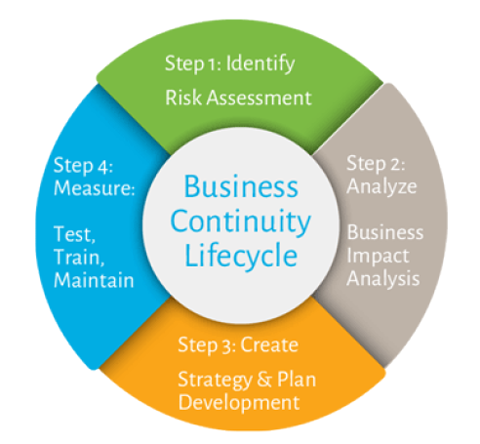

- Recovery capabilities are validated via the annual testing program through a global Readiness Assessment methodology and reported on a regular basis to local, regional and global governance committees, internal and external audit teams and industry regulators.
- The annual training and awareness program include a mandatory awareness session for all employees.

Business Continuity Management Process

The following process will be used to embed business continuity across the Company. The process follows the Business continuity lifecycle and will be the approach used for implementation in the Company
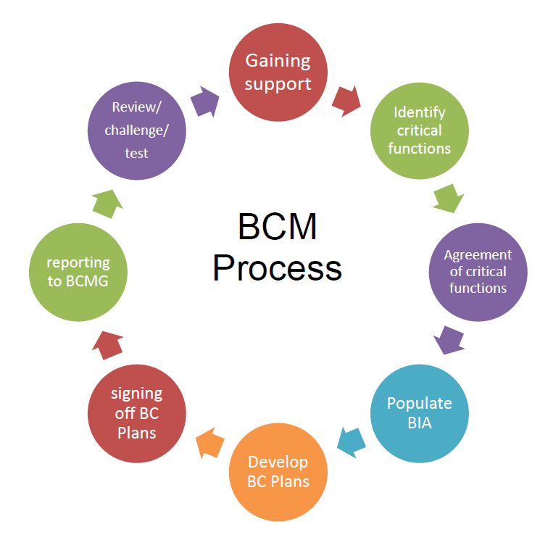
The process involves 8 key stages
Stage 1 - Gaining support: The management who collectively agree the business continuity management process, the identified critical activities and the work programme.
Stage 2 - Identify Critical Functions: The management carries out an initial scoping exercise to identify critical functions that form the prioritised work plan.
Stage 3 - Agreement of Critical Functions: The views of the ‘Lead owners ‘of critical functions identified in the scoping exercise are sought and reported to the management.
Stage 4 - Populating the BIA: Where critical functions have been agreed, meetings will take place with the ‘Lead owners’ to populate the risk and BIA template. This will be reviewed by the management to endorse recovery time objectives and ensure adequate arrangements are in place
Stage 5 - Developing BCP’s: After populating the BIA, Business Continuity Plans or disaster recovery plans will be developed if needed for each critical function
Stage 6 - Signing off BCP’s: Where BCP’s have been developed these will be signed off to which they relate. Management will be expected to highlight any issues that have wider business continuity implications
Stage 7 - Reporting to the Management: Following sign off with a summary of completed plans along with any issues that need to be brought to the attention of the Management will be reported.
Stage 8 - Review, Challenge, Test: In order for a BCP to remain current it should be exercised on a regular basis. The key outcomes from the testing phase the record of testing, timelines for testing, timelines for each recovery steps, SLAs derived confirmed RTO and RPO with testing result evidence and the final Post testing results.

8.2 BCM Methodology

- BCM is leveraged through collaborative risk assessment and business impact analysis (BIA).
- These activities establish a baseline business requirement from which future activities are aligned
- Through Strategy planning, development and deployment actionable plans are produced in line with business requirements
- Ongoing activities include Training and awareness, testing and Exercise and continuous improvement helps promote a continual state of readiness to enable mitigation and recovery activities, if required.
- The plan of BCM includes Assessment, policy, Corporate BCM strategy, BCM Program and structure, Training and awareness and BCM Assurance
- The process of BCM includes BIA, Operational risk and security assessment, Business continuous strategies, Emergency responses and operations, Develop and maintain BC plans, implement security and risk management, Communication, Incident and crisis management, Establish and implement BCM procedures, Incident and crisis management, Exercising and testing, Monitor and review, Maintain and improve
- This methodology is iterative and repeatable.

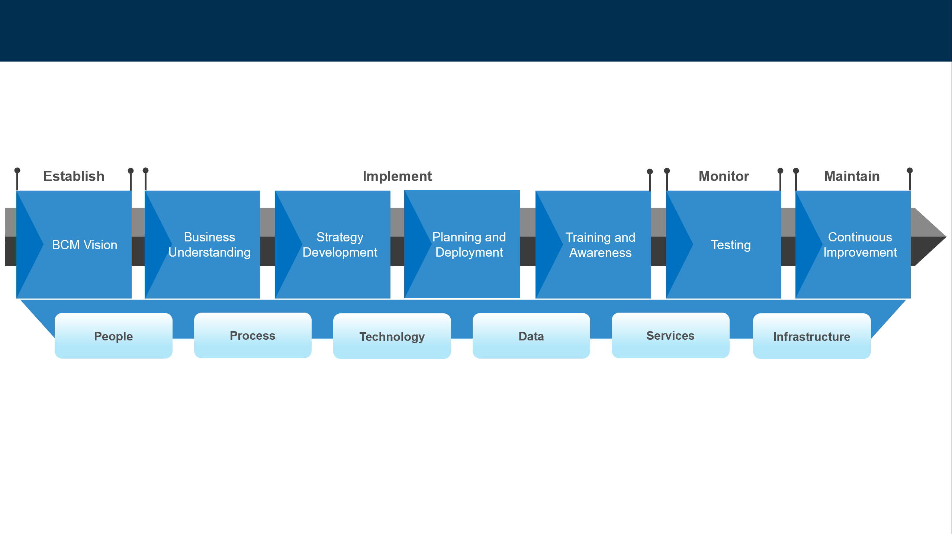

8.3 BCM Continual Improvement

Ensuring BCM objectives are met through periodic review, including self-assessment, and continual improvement of its plans, performance and documentation.
Periodic review and continual improvement shall be performed through:
- Regular review of changes to the business and risks that can result in business disruption, as well as the impact of such disruption, and the increase or decrease in risk appetite
- Reviewing and examining risk treatment and business continuity strategies and
- Approving response, incident management, communication, continuity and recovery plan(s) tailored to achieve the objectives.
- The review results be documented by the <ORG NAME>’s Business Continuity Head/Lead, and then reported to the Top Management.
- Address BC capability’s in consistency with industry standard, through preventive and corrective actions.
- Preventive and corrective actions shall be aligned with the Business Continuity Policy and BCM objectives at the acceptable level of risk, as may be determined by Top Management.
The initial Risk and Vulnerability analysis provides insights for:
- Company’s core business functions
- Critical processes
- Assets (anything of material value or usefulness)
- Extent of the contribution of each asset
- Exposure and susceptibility or processes and assets to interruption.
- Senior management will identify threats (risks) to core business function continuity and the processes, systems, information, people, assets, outsource partners and other resources that support or rely on them
- Systematically analyze likelihood and consequence of disruption and rate using the consequence ratings in the risk management framework
- Evaluate which disruption-related risks require treatment and identify treatments commensurate with BCP objectives and in accordance with the company’s risk appetite.
- Evaluation of vulnerability i.e., exposures, susceptibility, and effectiveness of existing controls
- Identification of potential improvements and creation of new measures to mitigate vulnerability, thereby reducing any residual risk to an acceptable level.

